1100_CPP Enrollment initiated by EV for Residential Combo Customer
Contract No. 4017167954
Material No. 88000105
Serial No. 29101109
Equipment No. 100005155094
Contract Account. 100059434942
Functional Location. 6002276639

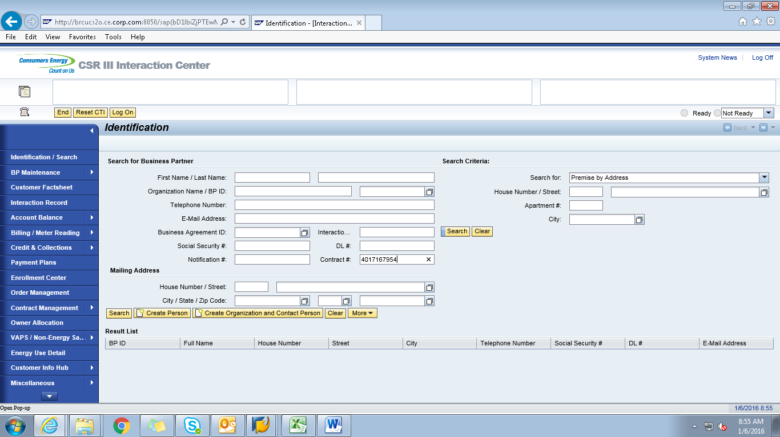

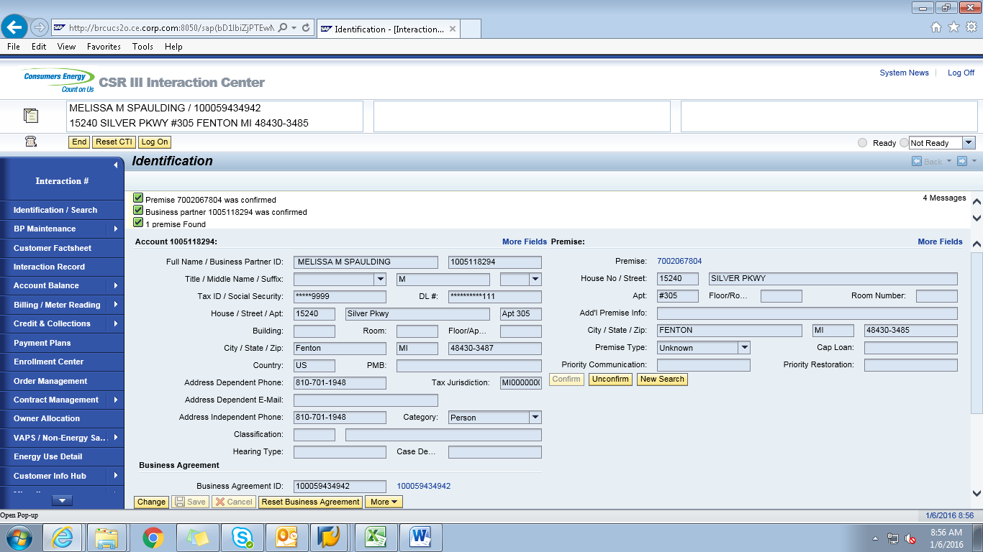

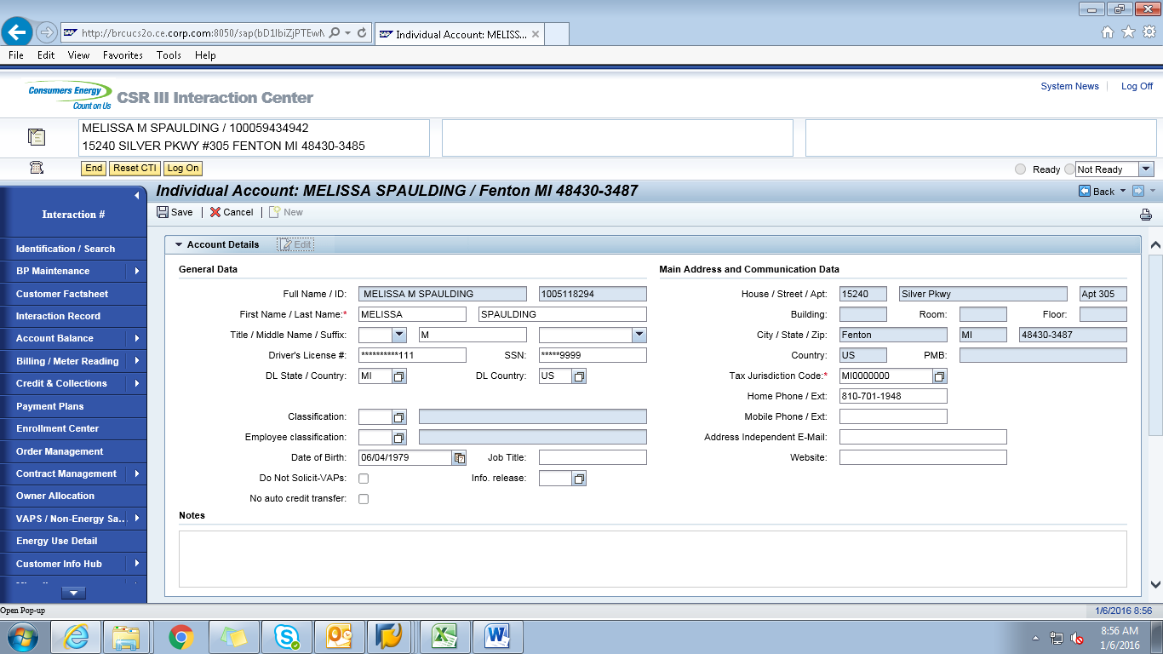

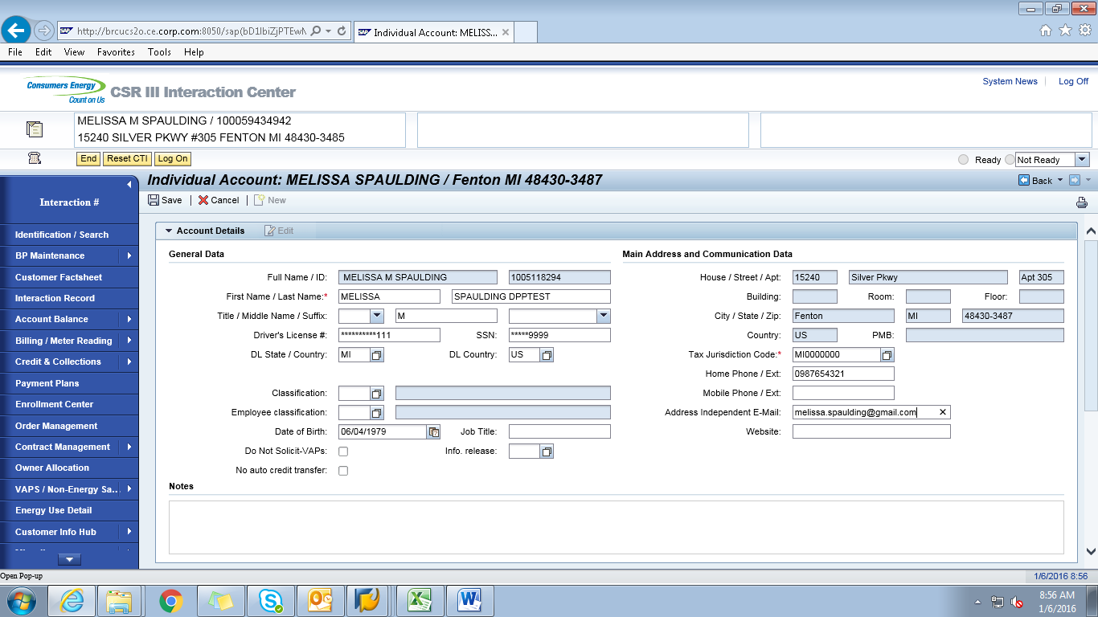

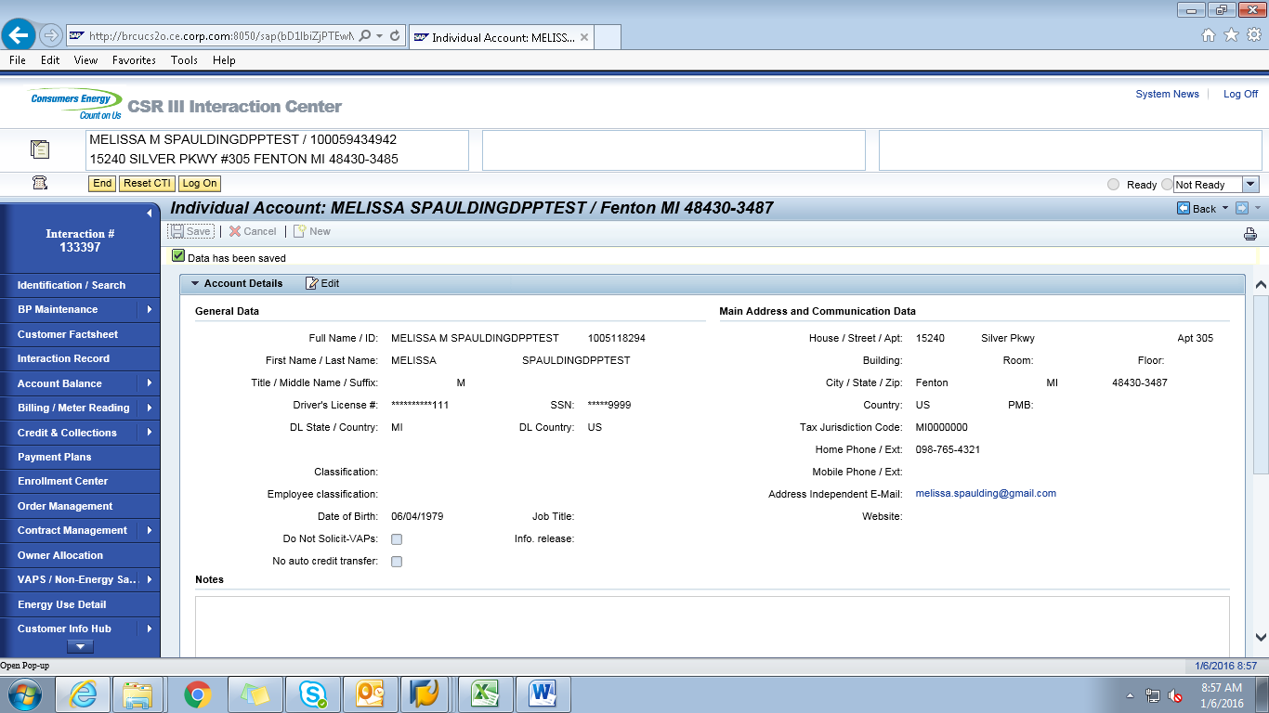
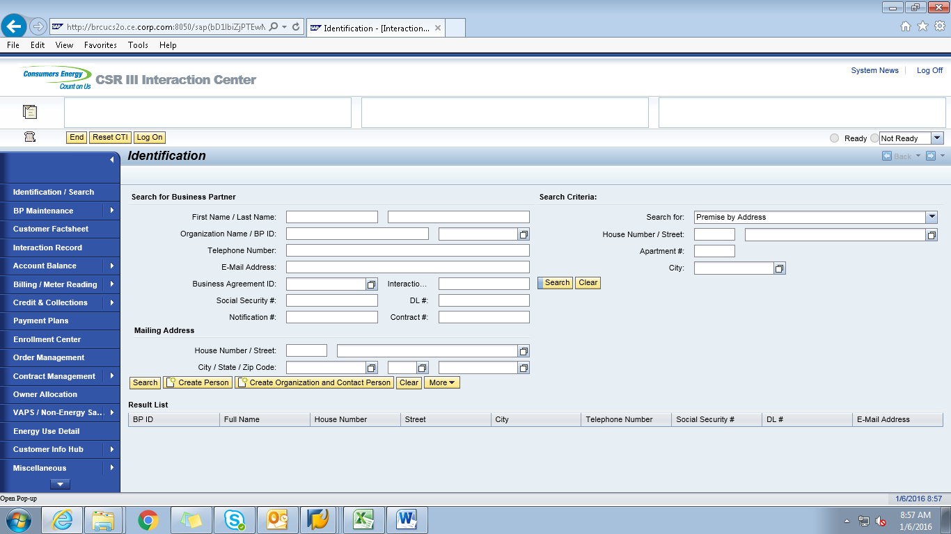
ECC
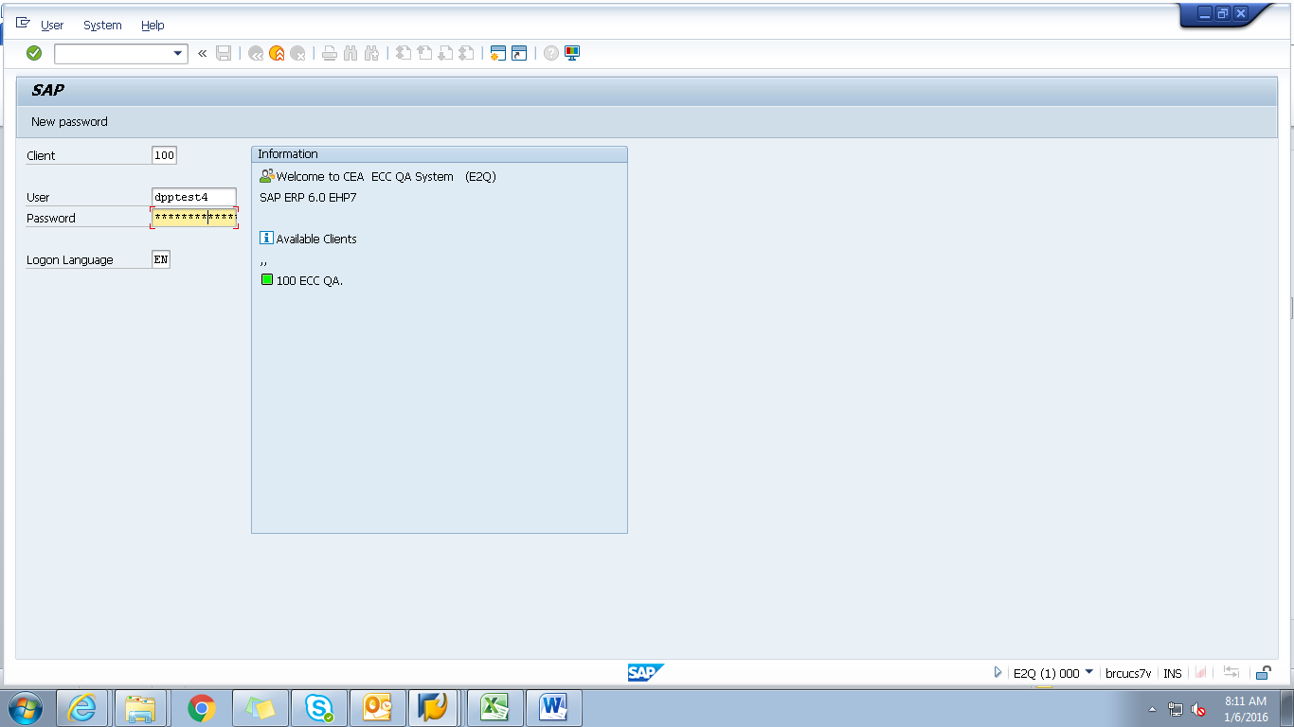
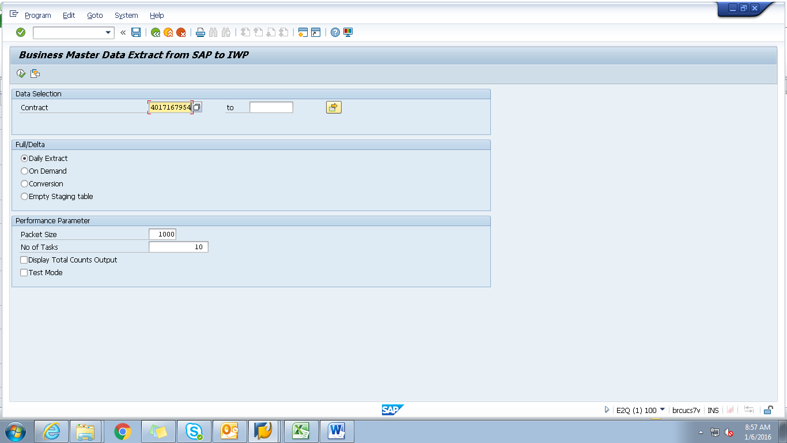

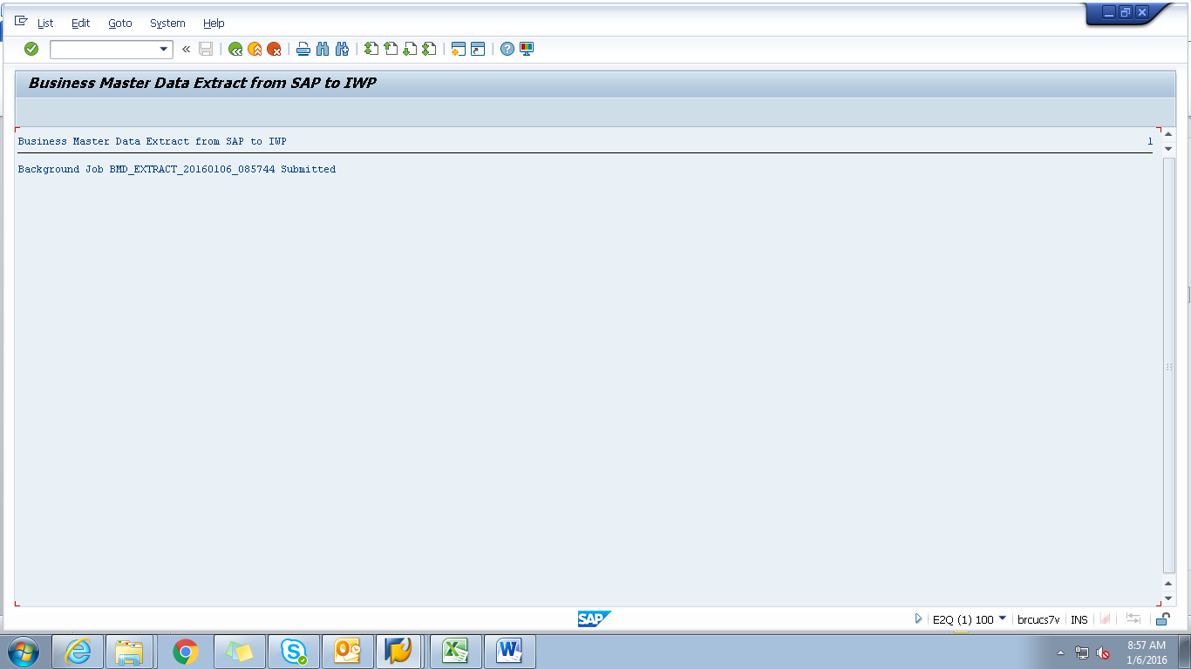

Obj tracking
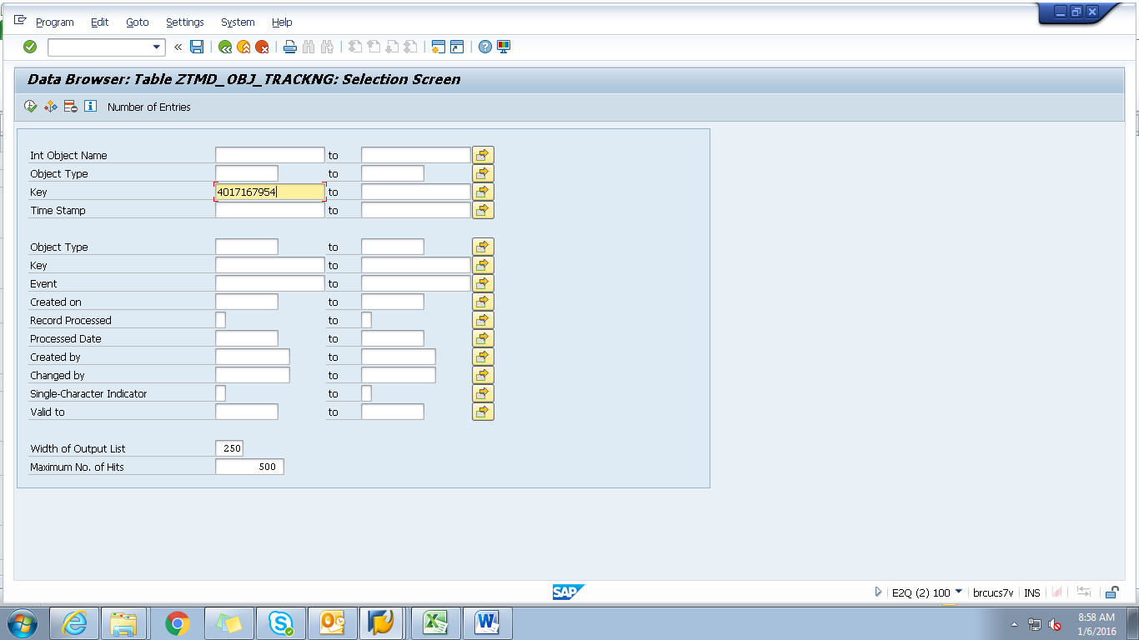
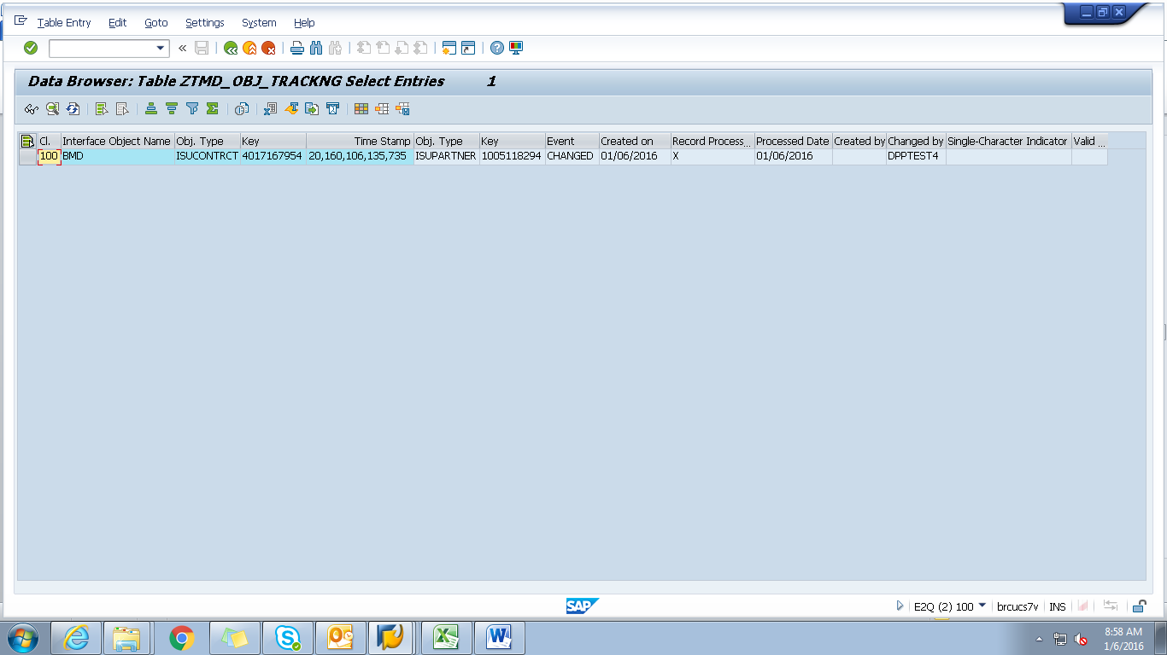
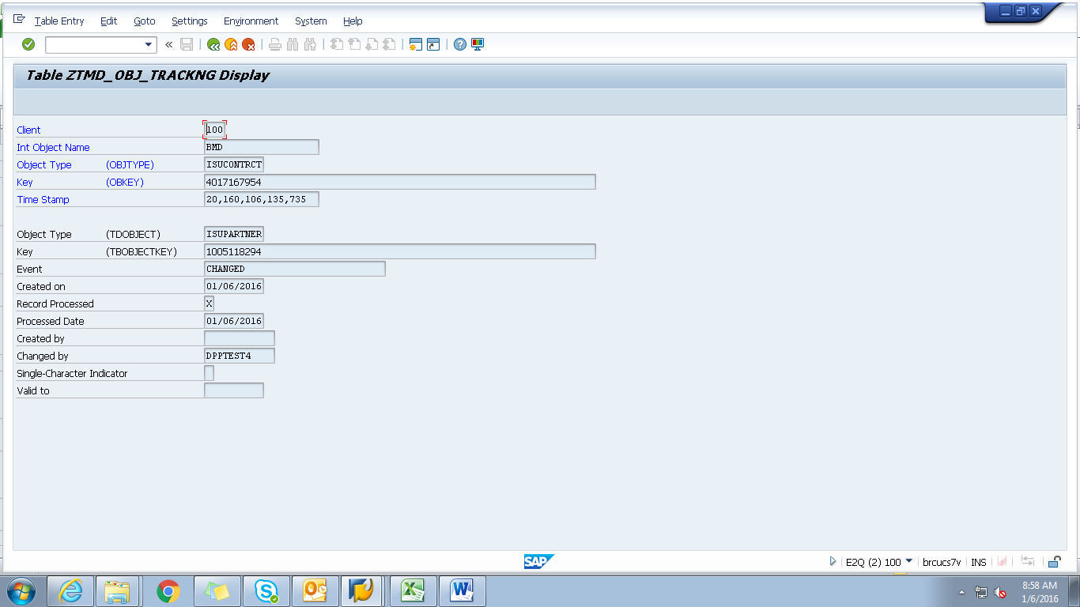
Spool
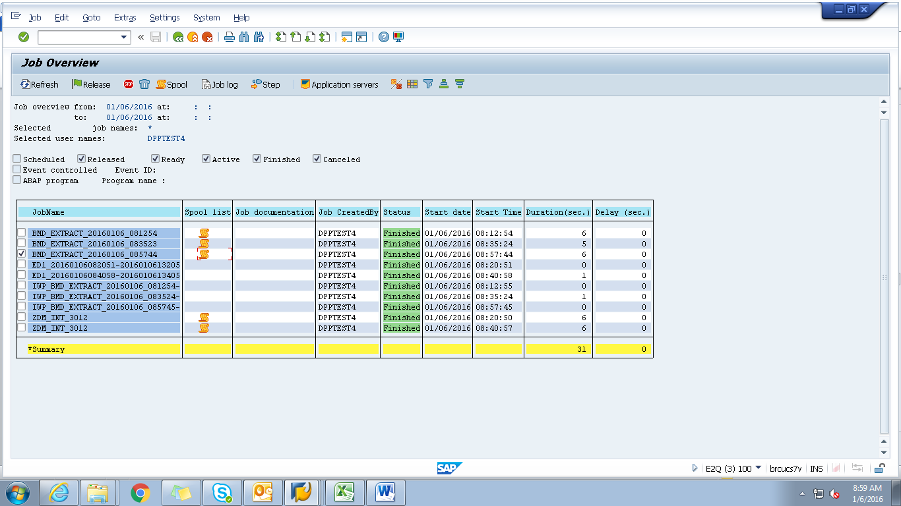
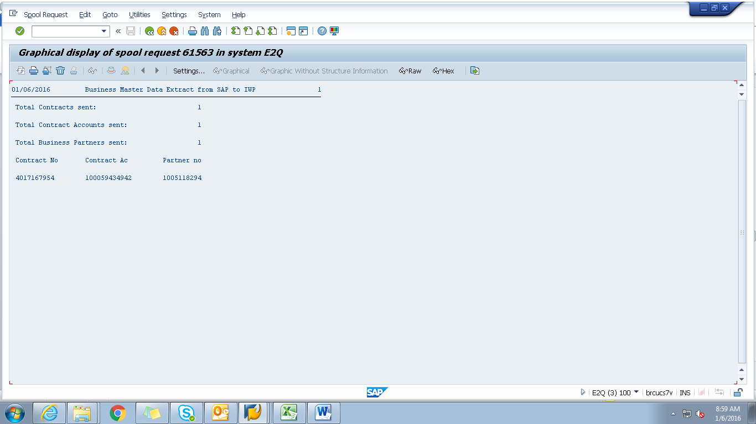
Payload
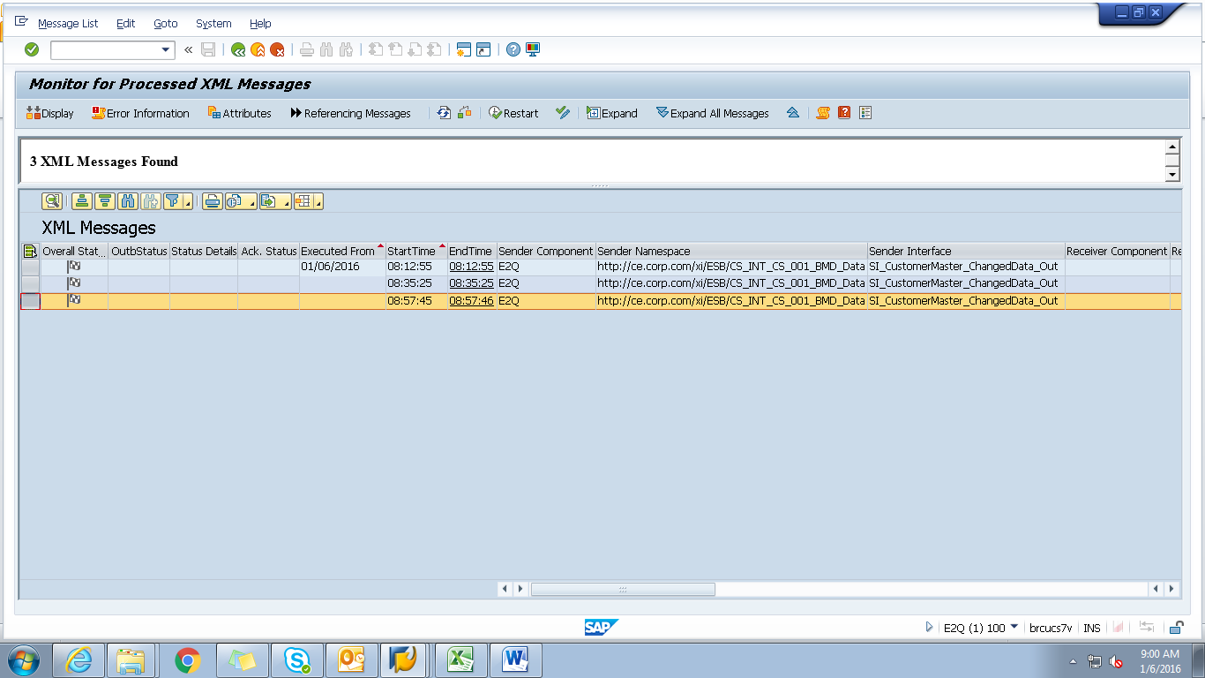

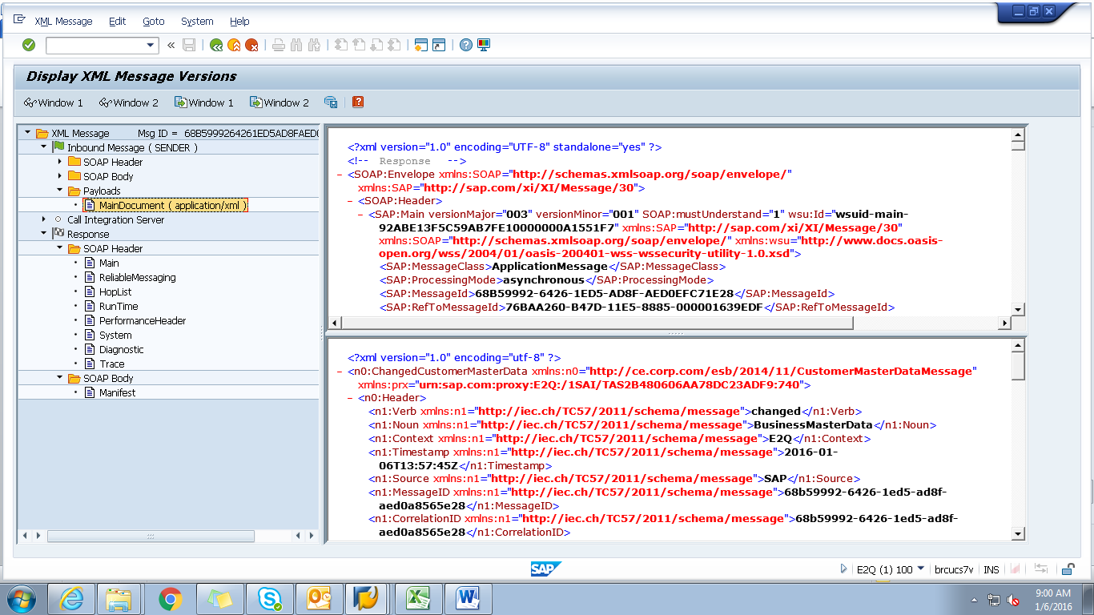

<?xml version="1.0" encoding="utf-8" ?>
- <n0:ChangedCustomerMasterData xmlns:n0="http://ce.corp.com/esb/2014/11/CustomerMasterDataMessage" xmlns:prx="urn:sap.com:proxy:E2Q:/1SAI/TAS2B480606AA78DC23ADF9:740">
- <n0:Header>
<n1:Verb xmlns:n1="http://iec.ch/TC57/2011/schema/message">changed</n1:Verb>
<n1:Noun xmlns:n1="http://iec.ch/TC57/2011/schema/message">BusinessMasterData</n1:Noun>
<n1:Context xmlns:n1="http://iec.ch/TC57/2011/schema/message">E2Q</n1:Context>
<n1:Timestamp xmlns:n1="http://iec.ch/TC57/2011/schema/message">2016-01-06T13:57:45Z</n1:Timestamp>
<n1:Source xmlns:n1="http://iec.ch/TC57/2011/schema/message">SAP</n1:Source>
<n1:MessageID xmlns:n1="http://iec.ch/TC57/2011/schema/message">68b59992-6426-1ed5-ad8f-aed0a8565e28</n1:MessageID>
<n1:CorrelationID xmlns:n1="http://iec.ch/TC57/2011/schema/message">68b59992-6426-1ed5-ad8f-aed0a8565e28</n1:CorrelationID>
- <n1:Property xmlns:n1="http://iec.ch/TC57/2011/schema/message">
<n1:Name>Stereotype</n1:Name>
<n1:Value>CustomerMasterData</n1:Value>
</n1:Property>
</n0:Header>
- <n0:Payload>
- <n2:CustomerMasterData xmlns:n2="http://ce.corp.com/esb/2014/11/CustomerMasterData#">
- <n2:Customer>
<n2:mRID>1005118294</n2:mRID>
<n2:name>MELISSASPAULDINGDPPTESTM</n2:name>
- <n2:CustomerAccounts>
<n2:mRID>100059434942</n2:mRID>
<n2:createdDateTime>2011-06-17T04:00:00Z</n2:createdDateTime>
<n2:paperBill>true</n2:paperBill>
<n2:paymentTerm>CE21</n2:paymentTerm>
<n2:type>RES</n2:type>
- <n2:CustomerAgreements>
<n2:mRID>4017167954</n2:mRID>
<n2:accountDeterminationID>RT</n2:accountDeterminationID>
<n2:createdDateTime>2011-06-17T04:00:00Z</n2:createdDateTime>
<n2:division>ELECTRIC</n2:division>
<n2:rateCategory>RS_1000</n2:rateCategory>
<n2:startMonth>00</n2:startMonth>
- <n2:Installation>
<n2:mRID>5001966342</n2:mRID>
</n2:Installation>
- <n2:ServiceLocations>
- <n2:UsagePoints>
<n2:mRID>6002276639</n2:mRID>
</n2:UsagePoints>
</n2:ServiceLocations>
- <n2:validityInterval>
<n2:end>9999-12-31T23:59:59Z</n2:end>
<n2:start>2011-06-20T00:00:00Z</n2:start>
</n2:validityInterval>
</n2:CustomerAgreements>
</n2:CustomerAccounts>
- <n2:Indicators>
<n2:type>SENIOR</n2:type>
</n2:Indicators>
- <n2:Indicators>
<n2:type>DLA EXCLUSION</n2:type>
</n2:Indicators>
- <n2:Indicators>
<n2:type>DPP EXCLUSION</n2:type>
</n2:Indicators>
- <n2:Indicators>
<n2:type>DO NOT MARKET</n2:type>
</n2:Indicators>
- <n2:MainAddress>
- <n2:streetDetail>
<n2:buildingName>0029854974</n2:buildingName>
<n2:name>Silver Pkwy</n2:name>
<n2:number>15240</n2:number>
<n2:suiteNumber>Apt 305</n2:suiteNumber>
</n2:streetDetail>
- <n2:townDetail>
<n2:code>48430-3487</n2:code>
<n2:country>US</n2:country>
<n2:name>Fenton</n2:name>
<n2:stateOrProvince>MI</n2:stateOrProvince>
</n2:townDetail>
</n2:MainAddress>
- <n2:Persons>
<n2:firstName>MELISSA</n2:firstName>
<n2:lastName>SPAULDINGDPPTEST</n2:lastName>
<n2:mName>M</n2:mName>
- <n2:electronicAddress>
<n2:email1>melissa.spaulding@gmail.com</n2:email1>
</n2:electronicAddress>
- <n2:landlinePhone>
<n2:localNumber>098-765-4321-</n2:localNumber>
</n2:landlinePhone>
</n2:Persons>
</n2:Customer>
</n2:CustomerMasterData>
</n0:Payload>
</n0:ChangedCustomerMasterData>

